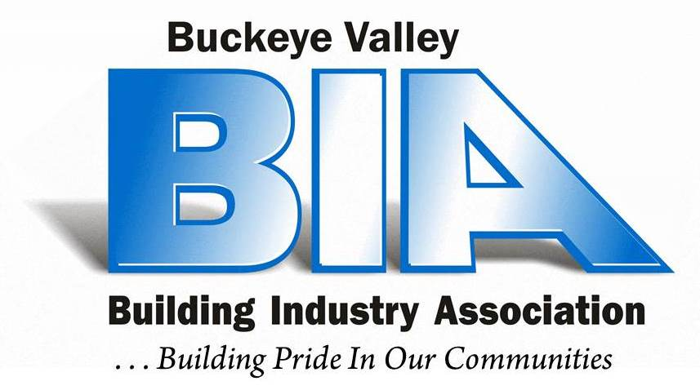

**Buckeye Valley Building Industry Association**

**CODE OF ETHICS**

Members of the Buckeye Valley Building Industry Association

Affirm that:

Home ownership should be within reach of every American family. That these homes provide the best value possible, and are built with high standards of safety, quality, materials, sanitation and livability. Furthermore, that every home be backed by builder service and integrity.

As part of our responsibility to the homebuyer, our community and country, BIA members pledge allegiance to the following principles and policies:

Honesty is our guiding policy in conducting business affairs. We will strive consistently to comply with the spirit of the law in financial transactions and business contracts, and manage our dealings with employees, subcontractors and suppliers with fairness.

We will work toward establishing a balance between legitimate environmental concerns and the need to develop and construct new housing. This will include the conservation of land and energy through consideration of natural environment as an intrinsic element in housing design.

To maintain our leadership as a progressive industry, we will continue to encourage research and development of new materials, building techniques, building equipment, and improve methods of home financing. As sound legislative proposals affecting our industry and the people we serve shall have our informed and vigorous support.

Finally, because we hold inviolate the free enterprise system and American way of like, we pledge our support to our associates, our local, state and national association, and all related industries concerned with the preservation of legitimate rights and freedoms.

We assume these responsibilities freely and solemnly, Mindful that they are part of our obligation as members of the Buckeye Valley Building Industry Association.

_________________________________

Member’s Signature of Agreement